Topic:  Solar System  Constellations | Class:  Science |  | Date:  11/24/12
Standards: | SC.1.N.1.1: Raise questions about the natural world, investigate them in teams through free exploration, and generate appropriate explanations based on those explorations.  LA.1.1.6.1: The student will use new vocabulary that is introduced and taught directly  LA.1.1.6.5: The student will relate new vocabulary to prior knowledge
Content Objective:  - The students will use the Constellation Lab to design and illustrate 2 of their own constellations.  - The students will demonstrate their understanding of constellations by completing the Constellation Writing activity with 90% accuracy. |  | Language Objective:  - The students will listen to the story Once Upon a Starry Night: A Book of Constellations while the teacher reads it and then discuss and raise questions in a discussion with the class.  - The students will use the key vocabulary when writing 2-3 sentences describing the constellation that they observed.
Key Vocabulary:  Constellations: groups of stars that appear to form the shapes of animals, people, or objects  Various Constellation Names - |  | Materials: (supplementary and adapted)  Book Once Upon a Starry Night: A Book of Constellations, Science text book, dried bean, black paper (3 half sheets per student), star stickers (1 sheet per pair of students), white or yellow chalk (1 per pair), pencil, Constellation Observation worksheet, Constellation Guide (1 per student)
High-Order Questions:

- Do you think that you could count every star in the sky? How could you count that many stars? (We could never count all of the stars in the sky, there are too many and some are very bright and some are very hard to see)

- How do people tell one star from another? (“One way is to use constellations”).

Time:  15 – 20 minutes  20 -25 minutes | Activities  Building Background:  To begin the lesson the teacher will read the book Once Upon a Starry Night: A Book of Constellations  - After the read-aloud the class will discuss what they read, the new vocabulary (Constellations), the teacher will begin the discussion by asking the High-Order Questions.  Links to Experience  - The students will create links to experience in the group discussion after reading the book. The teacher will also show pictures from the book and ask for the students to point out constellations that they see as well as if they have every noticed a constellation before.  Links to Learning:  - The students will read and discuss page 354 of their text.  - In teacher assigned pairs, the students will use the Constellation Lab to create and illustrate their own constellations. In the lab, students will be given dried beans, black paper, star stickers, and chalk. They will scatter the dried beans on a half sheet of black paper, the students will replace the scattered beans with star stickers and then connect the stickers to create a constellation with chalk. (The teacher will model this before allowing the students to start the lab).  - At home, the students go outside with their parent or guardian and observe the stars and moon. Using the Constellation Observation Worksheet, the students will record their observations with a 2-3 sentence description (using key vocabulary) and illustration. The students will also be given a Constellation Guide to compare their observations to.  Key vocabulary:  - Constellations: groups of stars that appear to form the shapes of animals, people, or objects  - Various Constellation Names
Student Activities (Highlight activities applied in this lesson)

Scaffolding: Modeling Guided Independent

Grouping: Whole Class Small Group Partners Independent

Process: Reading Writing Listening Speaking

Strategies: Hands-On Meaningful Links to Objectives

Review and Assessment
Individual Group Written Oral

- The students will be informally assessed during the group discussion. Student should be using key vocabulary terms during discussion.

- The students will be assed on the completion of their 2 self-created constellations.

- The students will be assessed on their Constellation Observation Worksheet which will include 2-3 sentences and an illustration of their observation.

Review Key Vocabulary:
The teacher will discuss new vocabulary terms and use the words often in discussions with the students. The teacher will also encourage the students to use their key vocabulary terms during the group discussion.

Review Key Content Concepts:
The following day student will be able to share their Constellation Observation assignment with the class.

Extensions: | The students will use the constellations that they created to write a short story about their constellation.
Books Used: | Science – Florida Edition  Grades: 1-3  Harcourt School Publishers  2007  ISBN: 0-15-343730-8 |  |  | Once Upon a Starry Night: A Book of Constellations  By: Jacqueline Mitton  Grades – PreK – 3  National Geographic  2009  ISBN: 9781426303913

Draw your constellation observation in this space.

Constellation Observation Worksheet
Write 2-3 sentences about your observation.

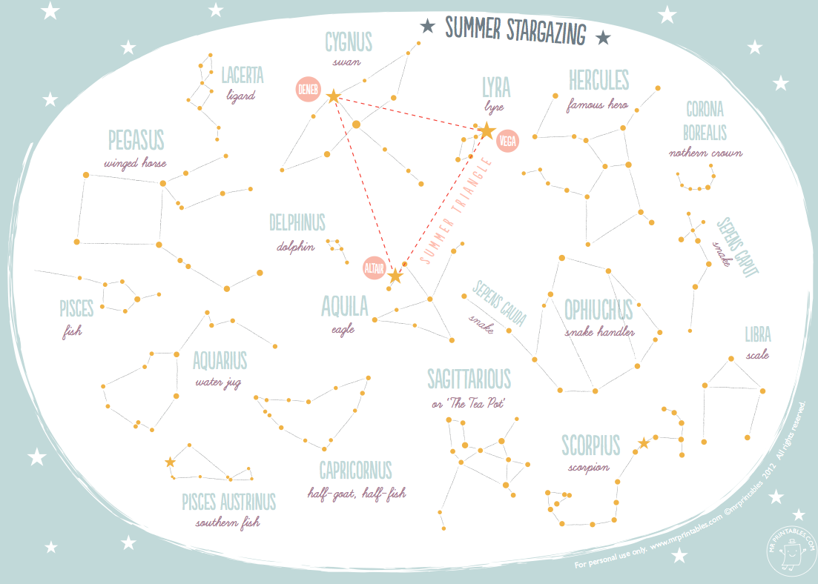
Constellation Guide

